Crop Classification and Clustering System

Project Id: AIML-4

Name :Atharv Rawat (Team Leader)
Class Roll Number: 40
University Roll Number :2028679
Section and Group: K - G1

Name : Kashish Rajput
Class Roll Number:15
University Roll Number : 2028444
Section and Group:K-G1

Name : Dhananjay Sharma
Class Roll Number:11
University Roll Number : 2028412
Section and Group: K-G1

TABLE OF CONTENTS

- Problem Description .................................................... 3
1.1 Dataset Description ................................................ 3
1.2 Flow diagram .......................................................... 4
- Modules for Project Implementation ................................ 5
2.1 Modules Used ........................................................ 5
2.2 Platform Used ...................................................... 6
- Machine Learning model/ Searching Technique used ......... 7
3.1 Supervised Learning Models ................................. 7
3.2 Unsupervised Learning (KMeans Clustering) ............ 8
3.3 Data Preprocessing and Feature Engineering ......... 8
- Evaluation metrics used ............................................. 9
- Results and Visualizations ......................................... 10
5.1 Supervised Model Comparison ............................ 10
5.2 PCA Variance Retention .................................... 11
5.3 KMeans Cluster Quality ..................................... 11
5.4 Important Findings from Feature Analysis ............ 12
- Conclusion and Future Scope .................................. 13
- References ............................................................... 14
- Appendix A: Model Settings and Deployment Notes ........ 15
Appendix B: Example User Interaction .......................... 15

- Problem Description
The Crop Classification and Clustering System is a Python-based machine learning application designed to support agricultural decision-making. The main objective of the project is to predict the most suitable crop for a given set of environmental and soil-related inputs, and to identify hidden patterns in the agricultural conditions using clustering. In practical farming, farmers and planners often have access to raw data such as rainfall, temperature, humidity, soil pH, nutrient availability, irrigation coverage, and yield history. However, these variables are spread across different scales and are not easy to interpret manually. The proposed system uses data preprocessing, feature engineering, supervised learning, and unsupervised learning to transform these raw values into meaningful crop recommendations and cluster insights.
This project is useful because agricultural conditions vary significantly across regions and seasons. A single crop may perform well in one district but may fail in another due to differences in rainfall, temperature, irrigation, and soil chemistry. Instead of relying only on intuition, the system learns from historical agricultural records and produces a prediction based on the input conditions. The supervised learning component answers the question: 'Which crop is most likely to be suitable?' The clustering component answers the question: 'Which similar agricultural situations belong to the same group?' Together, these two parts make the project both predictive and exploratory.
The system was developed as an end-to-end pipeline. It begins with exploratory data analysis to understand missing values, class imbalance, outliers, and feature distributions. It then performs data cleaning, encoding, scaling, and feature creation. After preprocessing, five different classification models are trained and compared. In parallel, PCA and KMeans are used to discover similarity groups among agricultural conditions. Finally, the best-performing models and preprocessing objects are saved using pickle so that they can be reused in the deployment script without retraining.
1.1 Dataset Description
Dataset Aspect | Description
Source | ICRISAT District-Level Agricultural Dataset
Approximate Records | ~42,733 rows
Coverage | 19 states and 279 districts
Time Period | 1966 to 2017
Main Features | Rainfall, temperature, humidity, irrigation, yield, fertilizer, soil moisture, pH, N, P, K, altitude, mechanization
Target in Supervised Task | Crop label assigned from agro-climatic rules
The dataset contains both continuous and categorical information. Continuous features such as rainfall, temperature, and yield capture climatic and productivity conditions. Categorical features such as state and district represent geographic context. The training process uses derived crop labels and historical patterns to convert the dataset into a classification problem. Because agricultural data often contains missing values and extreme values, the dataset is intentionally noisy and therefore closer to real-world conditions than a perfectly clean benchmark dataset.
1.2 Flow Diagram
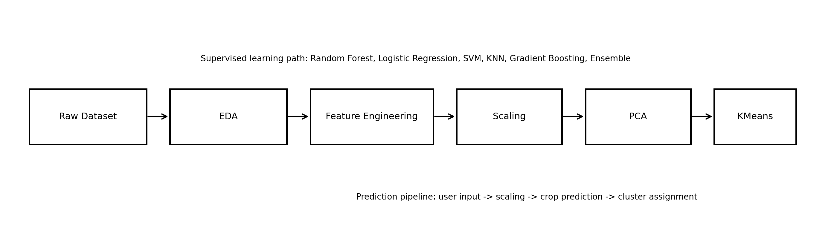
Figure 1: Overall workflow of the crop classification and clustering system.
The flow diagram shows the complete pipeline followed in the project. The raw dataset is first explored using EDA. The cleaned and engineered dataset is then scaled, transformed by PCA for clustering, and used to train the KMeans model. In the supervised branch, the same prepared data is used to train the prediction models. During deployment, the user input is passed through the same preprocessing pipeline to ensure that the prediction and clustering results remain consistent with training.

2. Modules for Project Implementation
This project uses a combination of standard Python libraries, scikit-learn utilities, and custom helper functions. The implementation was split into notebook files to separate exploratory analysis, preprocessing, and model training. This structure makes the project easier to understand, test, and debug. It also ensures that the final prediction script only loads saved artifacts instead of repeating training logic.
2.1 Modules Used

Module | Purpose | Important Functions / Classes Used
pandas | Data loading, cleaning, grouping, and tabular analysis | read_csv, isnull, groupby, describe, value_counts, corr
numpy | Numerical operations and array handling | array, exp, argsort, cumsum
matplotlib.pyplot | Visualization and plotting | figure, bar, plot, hist, imshow, subplots
scikit-learn.preprocessing | Data scaling and encoding | StandardScaler, LabelEncoder
scikit-learn.model_selection | Train-test splitting | train_test_split
scikit-learn.ensemble | Tree-based and boosting models | RandomForestClassifier, GradientBoostingClassifier, VotingClassifier
scikit-learn.linear_model | Baseline linear classification | LogisticRegression
scikit-learn.svm | Margin-based classification | SVC
scikit-learn.neighbors | Instance-based classification | KNeighborsClassifier
scikit-learn.cluster | Unsupervised clustering | KMeans
scikit-learn.decomposition | Dimensionality reduction | PCA
scikit-learn.metrics | Model evaluation | accuracy_score, f1_score, silhouette_score, confusion_matrix
pickle | Saving and loading trained objects | dump, load
os, sys | Path management and script control | path.join, sys.exit
Pandas is used extensively for reading the dataset, checking missing values, grouping records by crop and state, and preparing summary statistics. NumPy is used for mathematical operations in feature engineering, especially where formulas require exponential or array-based calculations. Matplotlib provides all the required plots in a reproducible way, which is important for evaluation and presentation. Scikit-learn forms the core of the machine learning pipeline, providing preprocessing, models, evaluation metrics, PCA, and clustering. Pickle is used to store trained models and preprocessing objects so that the final application can run quickly without retraining every time.
2.2 Platform Used:

Platform | Reason for Use
Jupyter Notebook | Used for EDA, preprocessing, experimentation, and step-by-step model development.
Visual Studio Code | Used for writing, organizing, and testing the final prediction script.
Python 3 | Primary language for data preprocessing, ML training, and deployment.
Windows / Local Environment | Used for running notebooks, saving .pkl files, and testing the CLI application.
Jupyter Notebook is especially useful for iterative data science work because each step can be executed independently and visualized immediately. Visual Studio Code is more suitable for the final application script because it provides cleaner code navigation, easier debugging, and a better editing environment for longer programs. Using both platforms together creates a practical workflow: Jupyter for research and experimentation, and VS Code for deployment and final testing.

3. Machine Learning Model/ Searching Technique Used
The project combines supervised learning for crop prediction and unsupervised learning for pattern discovery. This design was chosen because the final goal is not only to predict a crop, but also to understand the structure of the agricultural data. Five supervised models were compared so that the best-performing one could be selected objectively. In addition, KMeans clustering was used to group similar environmental conditions without using crop labels.
3.1 Supervised Learning Models
- Logistic Regression: used as a baseline linear model. It is simple, fast, and provides a reference point for comparison.
- Random Forest: used because it handles non-linearity, interactions between variables, and noisy agricultural data very effectively.
- Gradient Boosting: used to learn sequential corrections and test whether boosting improves performance over bagging.
- Support Vector Machine (SVM): used because it can perform well in high-dimensional feature spaces after scaling.
- K-Nearest Neighbors (KNN): used as a distance-based method to compare local similarity between samples.
- Voting Ensemble: used to combine the strengths of multiple models and improve stability.
The choice of five models was deliberate. They represent different learning philosophies: linear classification, bagging-based tree ensembles, boosting-based ensembles, margin-based classification, and instance-based learning. By comparing them on the same train-test split, the project avoids depending on a single algorithm and instead selects the model that performs best on the given dataset. In this project, Random Forest achieved the strongest overall performance, which is consistent with its ability to handle feature interactions and noise.
3.2 Unsupervised Learning: KMeans Clustering
KMeans was used to discover hidden groups in the feature space. Unlike supervised models, KMeans does not require target labels. It partitions the data into clusters by minimizing within-cluster distance. In this project, clustering is useful because agricultural conditions can form natural groups based on rainfall, irrigation, temperature, and soil characteristics. To make the clustering more effective, PCA was applied before KMeans. PCA reduced the dimensionality of the feature space and retained about 82.5 percent of the variance, which helped the clusters become more compact and more interpretable.
The optimal number of clusters was selected using the silhouette score. Multiple values of k were tested, and k = 5 gave the best observed silhouette score in the experiments. This does not mean the clusters are perfect; real-world agricultural data often overlaps because environmental conditions are continuous rather than sharply separated. However, the score is sufficiently useful to provide a meaningful cluster label for an input condition.
3.3 Data Preprocessing and Feature Engineering
Before training, the dataset was cleaned using missing-value handling and outlier control. Extreme values were clipped using percentile-based winsorization so that unrealistic outliers would not dominate the model while still preserving natural variability. Numerical features were then standardized using StandardScaler, since the models and PCA work better when the input features are on comparable scales.
The project also includes derived variables such as NPK_Balance, Water_Stress_Index, Fert_Efficiency, THI, and Year_norm. These features were created to capture relationships that are not directly visible in the raw columns. For example, NPK_Balance represents overall nutrient availability, while Water_Stress_Index combines rainfall and irrigation information to indicate how much moisture support is available. Such engineered features often improve predictive power because they encode domain knowledge directly into the model input.

4. Evaluation metrics used
Evaluation is one of the most important parts of the project because it shows whether the trained model generalizes to unseen data. Since crop classes are imbalanced, accuracy alone is not enough. A model that predicts only the most frequent class may still achieve deceptively high accuracy, so additional metrics are necessary.
Metric | Formula / Interpretation | Why It Was Used
Accuracy | Correct predictions / Total predictions | Measures overall correctness of the classifier.
Precision | TP / (TP + FP) | Shows how many predicted samples were truly correct.
Recall | TP / (TP + FN) | Shows how many actual samples were captured.
F1 Score | 2 * (Precision * Recall) / (Precision + Recall) | Balances precision and recall.
F1 Macro | Average F1 across classes with equal weight | Useful for class imbalance because each crop matters equally.
F1 Weighted | F1 weighted by class frequency | Shows performance while considering class support.
Silhouette Score | (b - a) / max(a, b) | Evaluates cluster separation for KMeans.
For the supervised models, accuracy and F1 scores were reported. Accuracy provides a broad picture of correctness, while F1 Macro is especially important because the crop classes are not equally distributed. F1 Weighted complements this by showing how the classifier performs when class frequency is taken into account. For the clustering part, the silhouette score was used because there are no true labels in KMeans. The silhouette score measures how well each sample fits within its cluster compared to other clusters.
The evaluation results showed that Random Forest clearly outperformed the other classifiers on the available dataset. Logistic Regression provided a reasonable baseline, SVM and KNN were also competitive, and the ensemble achieved stable results. Gradient Boosting initially underperformed due to the chosen hyperparameters, demonstrating why tuning is essential before judging a model. For clustering, the silhouette score was moderate, which is expected for real agricultural data where clusters naturally overlap.

5. Results and Visualizations
This section summarizes the major experimental results and explains the visual outputs generated during the project. The plots are produced directly using matplotlib so that they are reproducible, easy to regenerate, and consistent with the notebook pipeline.
5.1 Supervised Model Comparison
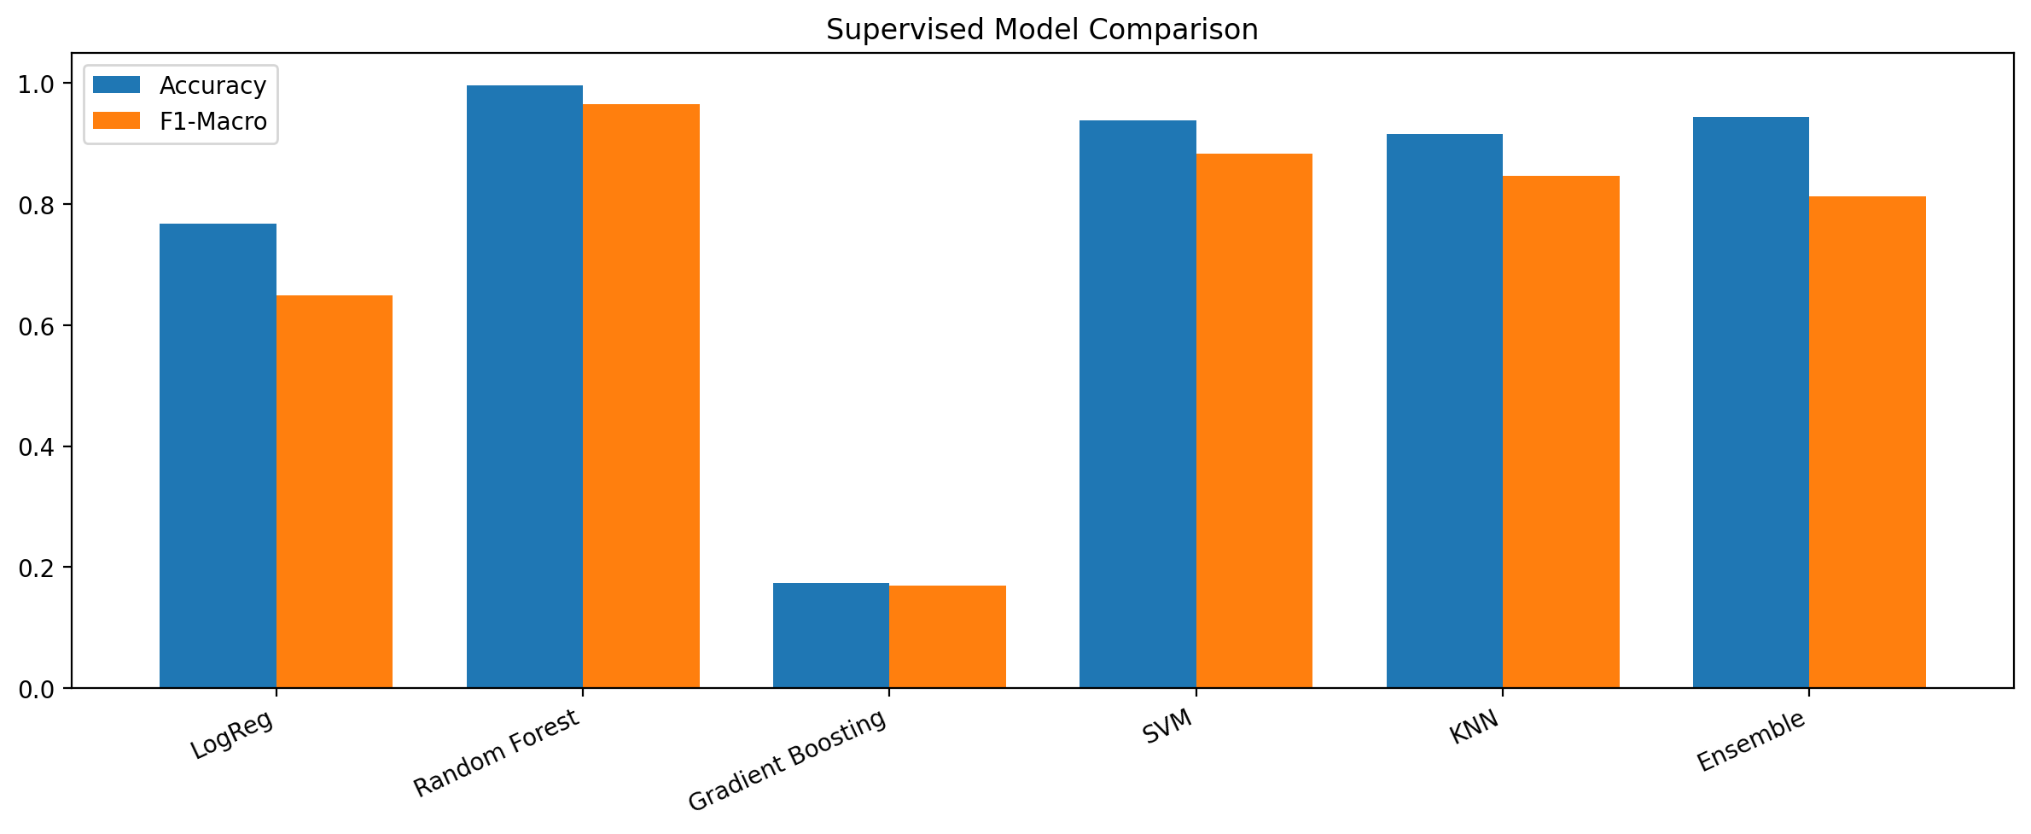
Figure 2: Comparison of supervised models using accuracy and F1-Macro.
Model | Accuracy | F1-Macro | F1-Weighted
Logistic Regression | 0.7681 | 0.6488 | 0.7755
Random Forest | 0.9966 | 0.9655 | 0.9966
Gradient Boosting | 0.1739 | 0.1696 | 0.2086
SVM | 0.9387 | 0.8833 | 0.9390
KNN | 0.9163 | 0.8474 | 0.9148
Ensemble (Voting) | 0.9434 | 0.8125 | 0.9449
The results show that Random Forest is the best model for this dataset. It achieved the highest accuracy and the highest F1-Macro score, which makes it the most reliable option for deployment. Logistic Regression served as a baseline and performed reasonably well, but not as strongly as the tree-based models. SVM and KNN also performed well after scaling. The ensemble model combined multiple learners and produced stable results, though it still did not surpass Random Forest. Gradient Boosting underperformed in the initial configuration, suggesting that the hyperparameters needed tuning.

5.2 PCA Variance Retention
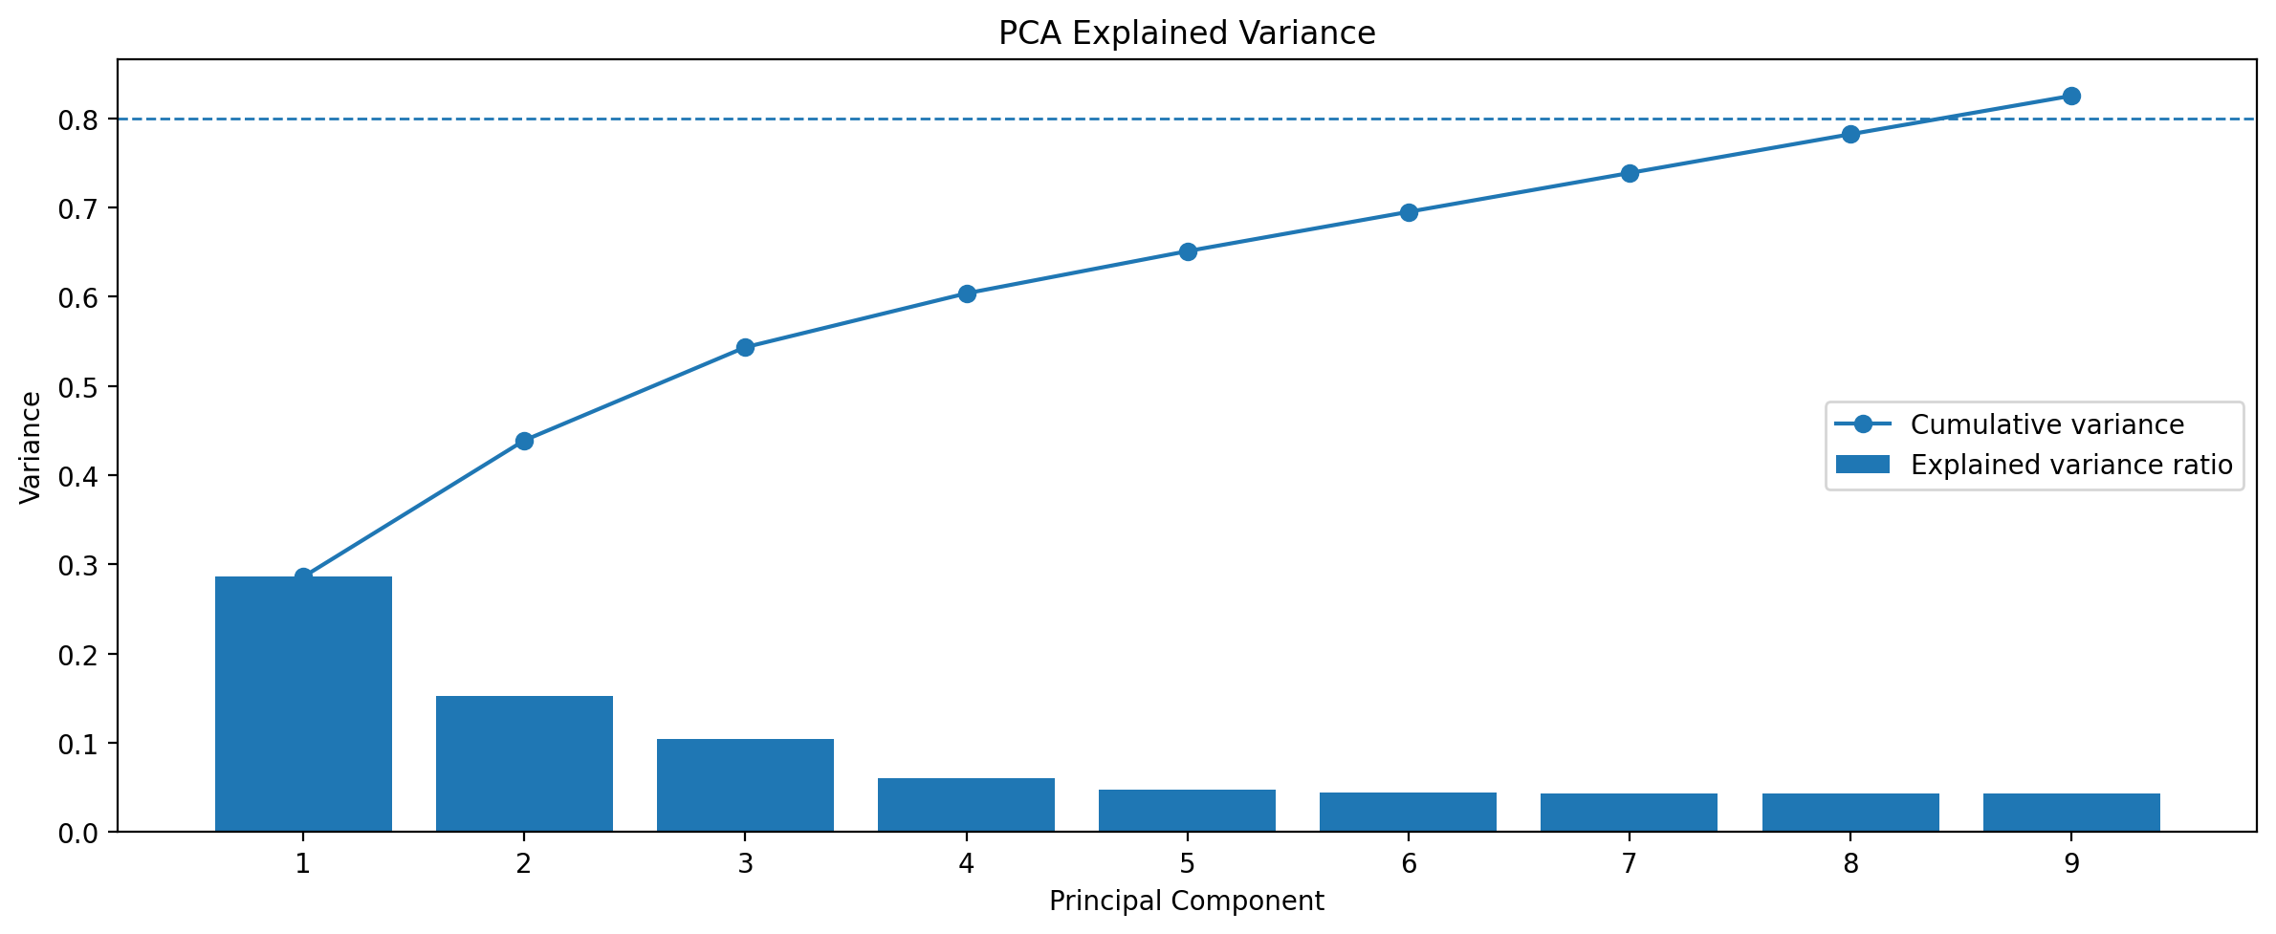
Figure 3: PCA explained variance ratios and cumulative retained variance.
The PCA plot shows that the first few principal components capture a substantial portion of the variance, but not all of it. Using a variance retention threshold of 0.8 allowed the model to keep more than 80 percent of the information while still reducing dimensionality. This balance is important because PCA should simplify the space without destroying the structure needed by KMeans. The cumulative curve confirms that the selected number of components satisfies the retention target.
5.3 KMeans Cluster Quality
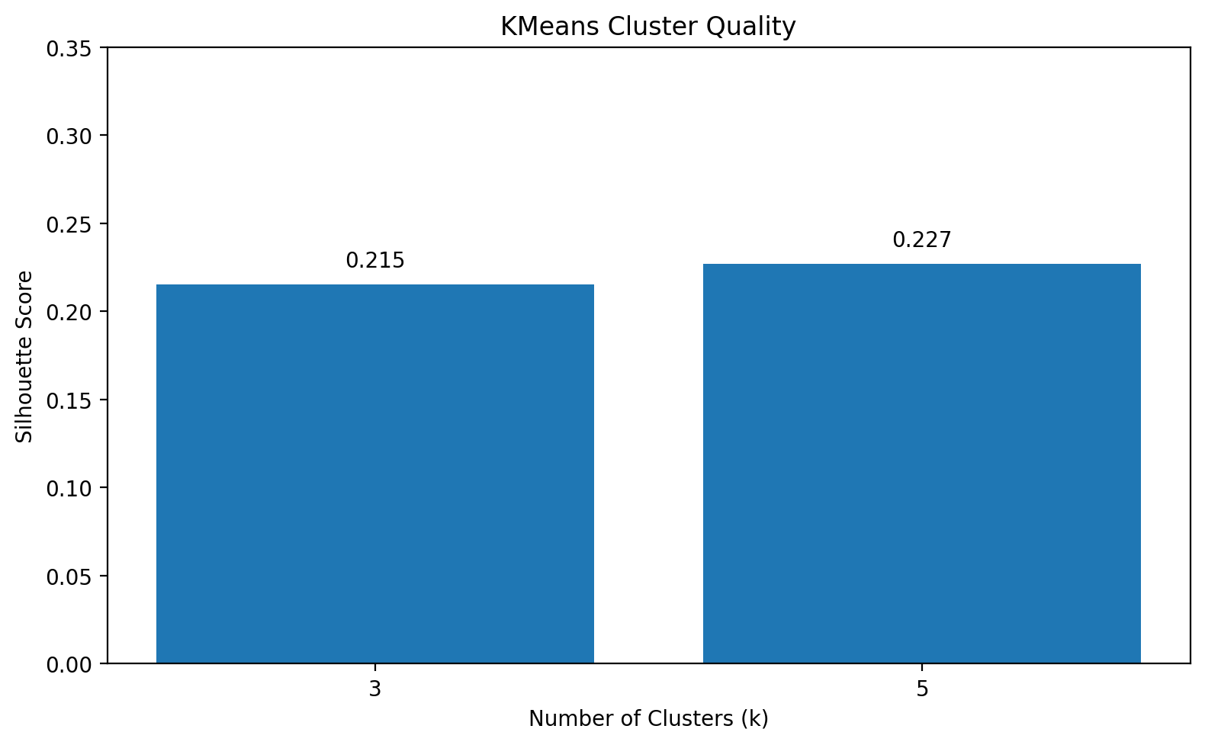
Figure 4: Silhouette scores for selected KMeans cluster settings.
The silhouette plot indicates that k = 5 gave the highest observed silhouette score among the tested settings. Although the score is not extremely high, it is acceptable for a complex real-world agricultural dataset where boundaries between groups are naturally soft. This means the clusters are useful as a secondary insight layer, even if they are not perfectly separated.
5.4 Important Findings from Feature Analysis
Rank | Feature | Interpretation
1 | N_kg_per_ha | Nitrogen requirement was one of the strongest drivers of crop choice.
2 | NPK_Balance | Combined nutrient availability captured fertilization patterns well.
3 | Rainfall_mm | Rainfall strongly influenced crop suitability and productivity.
4 | State_encoded | Geographic context remained important in the final model.
5 | Temperature_C | Temperature helped separate crop-specific growth conditions.
Random Forest feature analysis suggested that nutrient-based variables and environmental conditions were the main predictors. This is logically consistent with agricultural science: crop suitability depends heavily on water availability, soil nutrients, temperature, and location. The importance ranking also supports the feature engineering step because derived variables such as NPK_Balance and Water_Stress_Index directly encode agronomic relationships.

6. Conclusion and Future Scope
The Crop Classification and Clustering System demonstrates an end-to-end machine learning workflow for agricultural decision support. The project successfully combines data cleaning, feature engineering, model comparison, dimensionality reduction, clustering, and deployment-ready prediction logic. Among the supervised models, Random Forest emerged as the best performing classifier on the available dataset. In parallel, PCA and KMeans were used to identify similar agricultural conditions and provide a cluster-based interpretation of user input.
The project is useful because it turns raw agricultural data into actionable insights. The supervised component predicts the most suitable crop, while the clustering component helps detect whether a new input belongs to a known pattern in the data. This dual design makes the system more informative than a single prediction model. It also shows the practical value of combining explainable preprocessing with machine learning algorithms rather than relying only on a black-box predictor.
There are several directions for future improvement. First, the system can be connected to live weather APIs so that predictions use current climatic data. Second, the application can be converted into a web interface using Streamlit or Flask for easier use by non-technical users. Third, additional models such as XGBoost or CatBoost can be evaluated if more optimization time is available. Fourth, spatial visualization can be added to show crop suitability across districts and states. Finally, a recommendation engine can be created that not only predicts the crop but also suggests irrigation and nutrient adjustments.
Overall, the project is a strong example of a practical machine learning pipeline. It covers both prediction and unsupervised analysis, uses proper model evaluation, and is deployable through saved artifacts. The design choices were made to balance accuracy, interpretability, and implementation simplicity.

7. References
Books
- Aurélien Géron : Hands-On Machine Learning with Scikit-Learn, Keras, and TensorFlow
- Wes McKinney : Python for Data Analysis
- Christopher Bishop : Pattern Recognition and Machine Learning
Online Resources
- GeeksforGeeks: https://www.geeksforgeeks.org/
- Stack Overflow: https://stackoverflow.com/
- Scikit-learn documentation: https://scikit-learn.org/
- Pandas documentation: https://pandas.pydata.org/
- Matplotlib documentation: https://matplotlib.org/
The above references were used for Python syntax, machine learning concepts, preprocessing methods, and plotting utilities. The dataset and crop-related assumptions were based on the ICRISAT agricultural data context and common agronomic practice.

Appendix A: Model Settings and Deployment Notes
The final application uses a consistent preprocessing pipeline so that the training and prediction environments match. The same scaler fitted during preprocessing is loaded in the prediction script, followed by the PCA transformer used for the clustering branch. The supervised models operate on the scaled feature vector, while the unsupervised branch first applies PCA and then passes the reduced vector to KMeans. This prevents dimension mismatch and ensures that new inputs are evaluated in the same transformed space as the training data.
Component | Saved Artifact | Role in Deployment
Feature Scaling | scaler.pkl | Transforms raw input into standardized numeric form.
Dimensionality Reduction | pca.pkl | Reduces feature space before clustering.
Clustering | kmeans.pkl | Assigns the input to the closest agricultural cluster.
Crop Prediction | random_forest.pkl | Produces the final crop recommendation.
Encoders | label_encoder_*.pkl | Converts state, district, and crop names to numeric codes.
The model training notebook uses a train-test split for the supervised part, while KMeans is trained on the full feature set because it is unsupervised and does not require labels. This design choice is important: the classification branch evaluates generalization on unseen data, and the clustering branch extracts structure from the full normalized feature space. During viva or evaluation, this distinction should be clearly explained because it shows a correct understanding of supervised and unsupervised learning.
Appendix B: Example User Interaction
- Mode 1: The user enters rainfall, temperature, humidity, soil properties, nutrient levels, and geographic information.
- Mode 2: The user selects a crop name and the script displays ideal conditions and summary statistics from the dataset.
- The script returns the predicted crop along with the cluster group assigned by KMeans.
- The top-3 probability display helps the user understand alternative crop choices when the classifier supports probabilities.

